Content table
CONTROL CHANGES 1
1. OBJECTIVE 1
2. SCOPE 1
3. TERMS AND DEFINITIONS 1
4. REFERENCE DOCUMENTS 2
5. DESCRIPTION 2

CONTROL CHANGES
item | Description | Date | Approval cycle
1 | Created on | 2/3/2023 | Created by:  Angélica Martínez  Review by  Andrés Pirela  Approved by:  Raúl Zarate  Updated by  Andres Pirela
2 | Updated | 06/06/2024 | Created by:  Andrés Pirela  Approved by:  Juan Benavides

OBJECTIVE
To indicate the steps to request contracts for an agent with OSCAR, as well as to complete the contract information in Salesforce.

SCOPE
Applies to agents requesting the Oscar contract through the ARC for the first time or requiring an add state.

TERMS AND DEFINITIONS
ARC: Platform that allows viewing the agent's book of business, production, and commissions.

Carrier: Insurance company or entity with which Claro Insurance maintains contracts, and through these, agents associated with us sell their products.

Salesforce: Digital tool that contains information about the company's agents and clients.

Agency: Organization recognized by Oscar as the recipients of commissions.

GA: Organization to which Override payments are directed.

Commissions: Payments made by the Carrier for the membership and belong to the agent.

Override: Amount paid by the Carrier to the GA as extra compensation for volume.

Opportunities: An agent who gives a positive response is categorized, and the record moves to the opportunities object, which applies to contracting.

REFERENCE DOCUMENTS
N/A

DESCRIPTION
- Log in to Salesforce and find the contracts requested for Oscar as below:

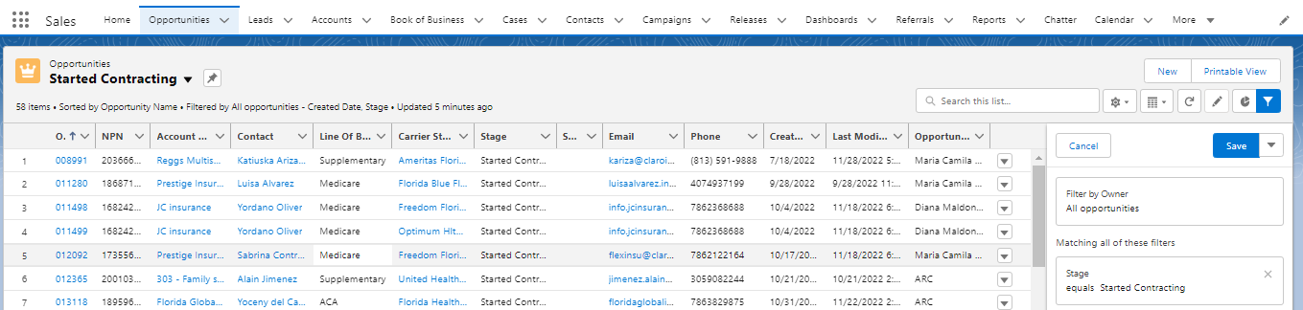

(1) Click on Opportunities
(2) Choose the started contracting list
(3) Look up for the Oscar opportunities.

- To request the contract, you must go to the agency link as below

All Insurance Link:
https://hiosc.ar/XS0HB4

LINK DE OSCAR PARA COMFORT
https://hiosc.ar/BZ9XKM

LINK DE OSCAR PARA ARPHA
https://hiosc.ar/6GQ8GB

LINK DE OSCAR PARA METAVISTA
https://hiosc.ar/5ZVF08

LINK DE OSCAR PARA ESTRELLA
https://hiosc.ar/Z68A09

ALL INCLUSIVE FINANCIAL SOLUTIONS INC
https://hiosc.ar/3BFGDC

BORTEC
https://hiosc.ar/HHSQRW

CAREPOINT
https://hiosc.ar/X37M73

- Once the page is opened choose and select the states where the broker is licensed.
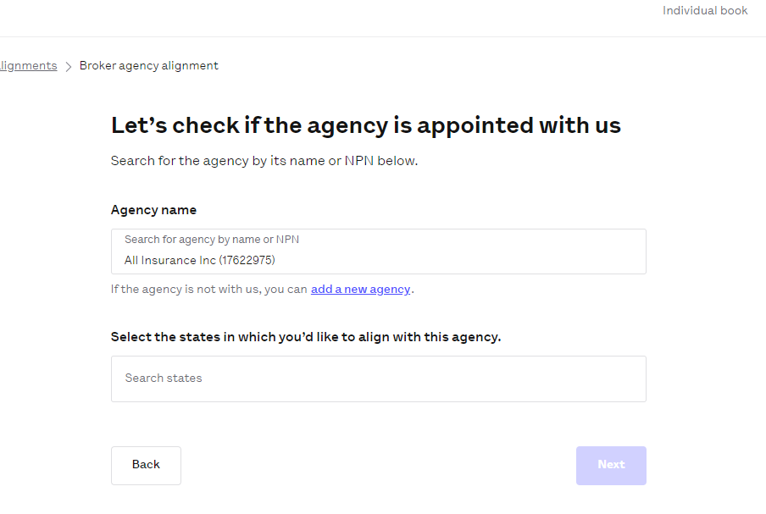
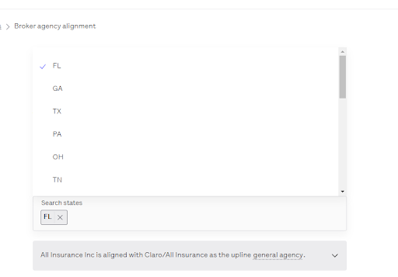
- Then review and save changes.
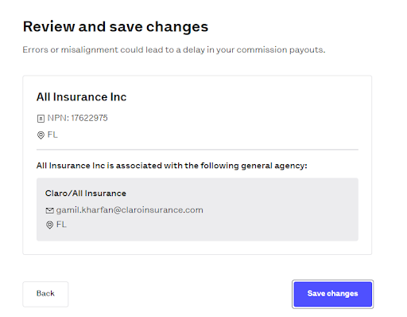

- Enter the agent’s NPN and the system will show a pop-up with the information located on their connection with NIPR.

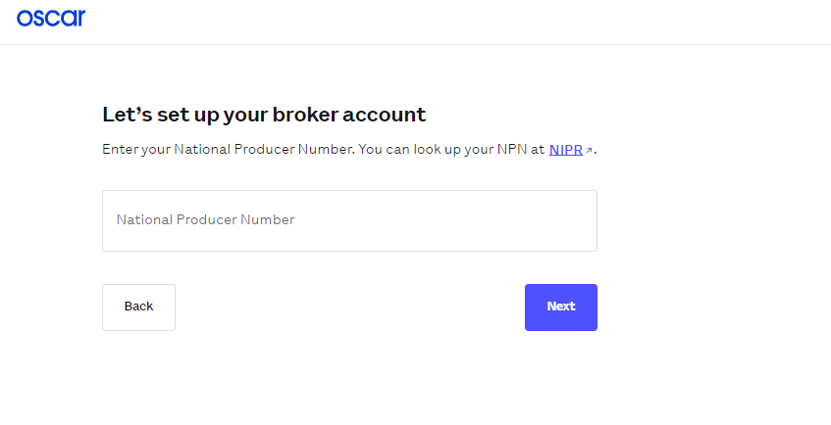
- Then confirm the type of register we are creating, the agents of Claro usually are independent under an agency, therefore we choose the option number two as below:
“Yes, I work for an agency, but I’m not the principal agent”

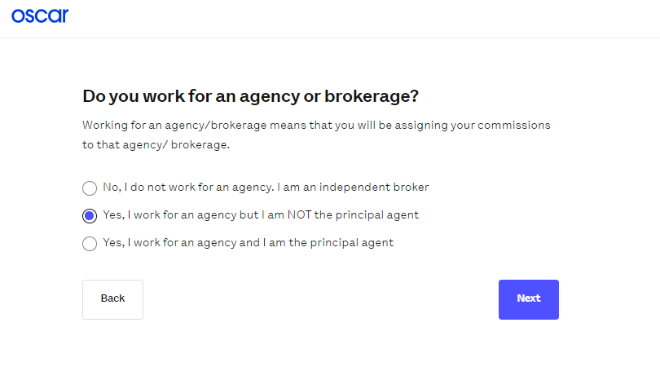
- Complete the information requested and create the password: Claro2024* and click on “Sign up!”
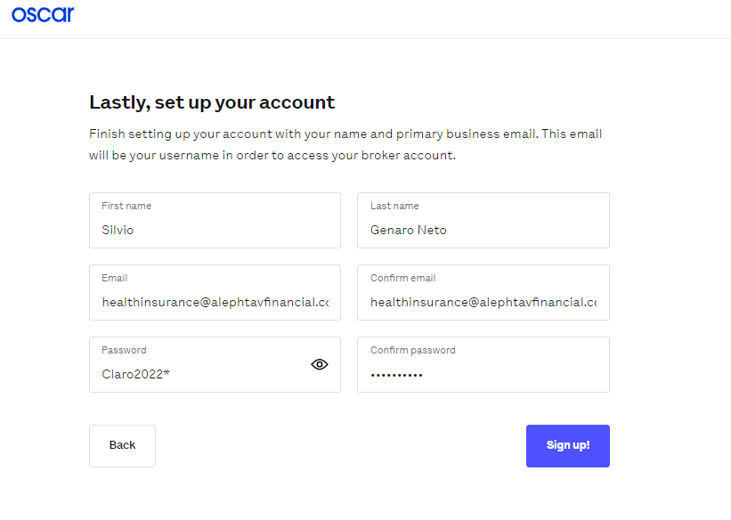

- On the next screen, a message will appear indicating that a verification message will be sent to the agent. Here, you just need to click on "Continue to broker account."
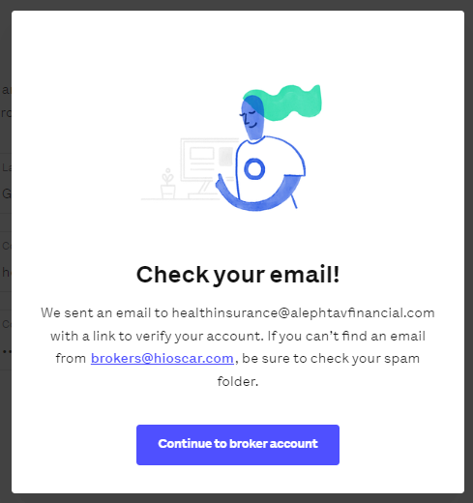
- Once in the agent's account, go to the tab that says "Get appointed to sell IPF and Small Group."
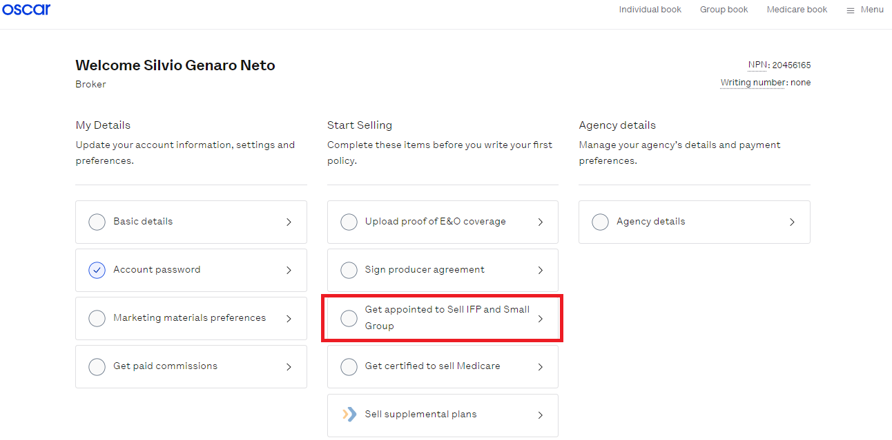
- On the next page, you should request an appointment only from the option that says "Oscar."

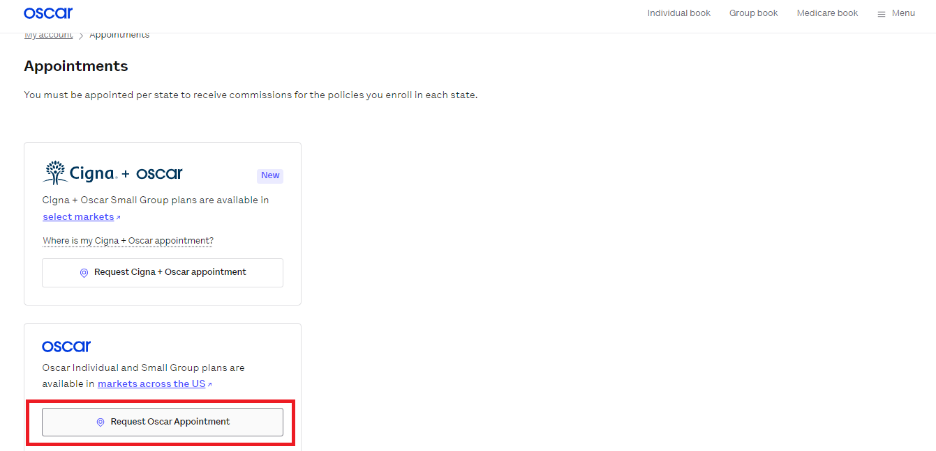
- Once on this page, select the state for which the appointment will be requested. The application will ask for the license number and whether the agent is a resident or not in the state. If it is a license of a resident, it will ask for county information: (Only when we ask for a FL Appointment.)

- Answer the following questions:
"Which products do you plan on selling?" Select "Individual" –
"Are you writing through an agency?" Select "Yes". A dropdown list wil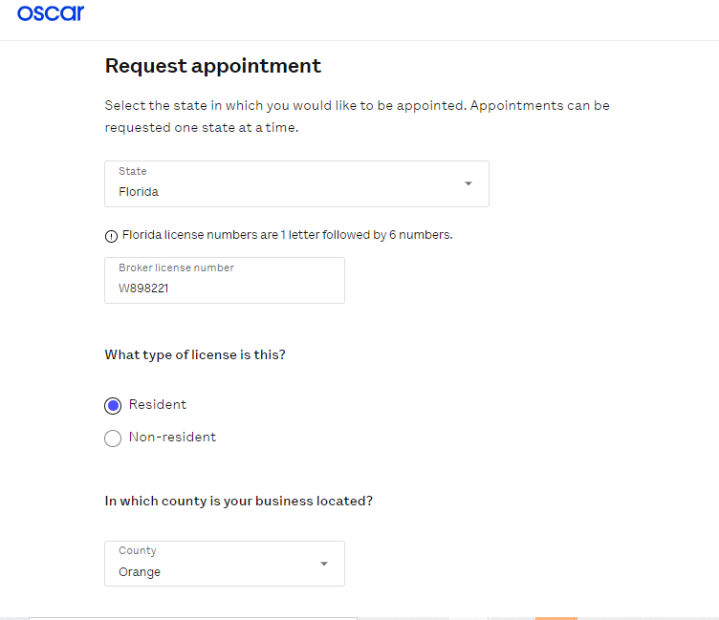l appear, search for "All Insurance", and enter the EIN as "364811052", although this last one is only for reference because once "All Insurance" is selected, it will appear automatically.

Considerations: When managing opportunities for
Estrella Insurance agency at this step, you should select the agency 'Estrella Health Solution' EIN: 834285869. Similarly.
Bortec Insurance, you should select the agency 'Bortec Insurance' EIN: 831961525."
Arpha you should select the agency 'Arpha' EIN:."
Metavista you should select the agency “metavista EIN:."

"In the following question: 'Do you want to write Individual & Family Plans business through a General Agency?' you should choose 'Yes' and search for 'Claro/All Insurance' in the dropdown list."

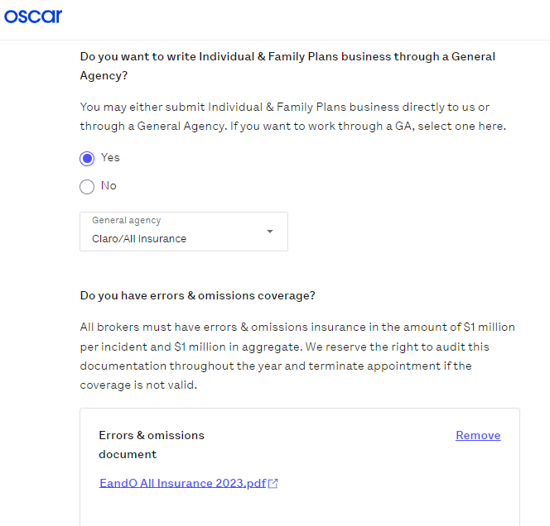
"In the question 'Do you have errors & omissions coverage?' you should upload the E&O coverage from All Insurance and choose the option that says 'Enrolled agents of All Insurance Inc'. Then, enter the coverage start and end dates as '10/01/2023 - 10/01/2024' (or the corresponding dates for the current year)."

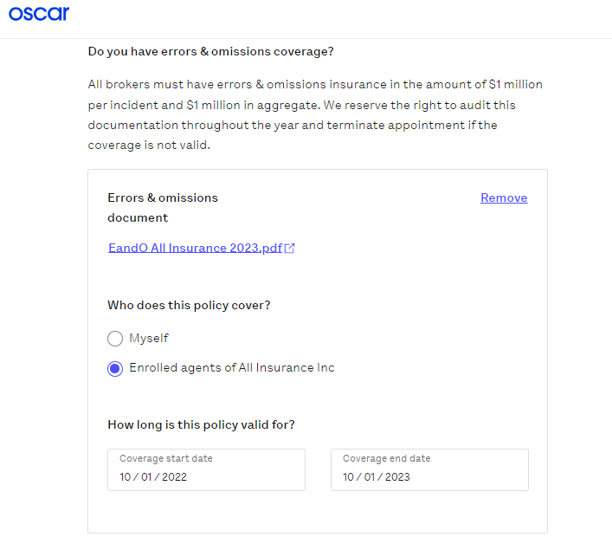

- Click on 'E-sign contract'; this will direct you to an electronic signature where you must enter the agent's name exactly as done in step 6 and select the checkbox provided. Finally, click on 'Submit Request
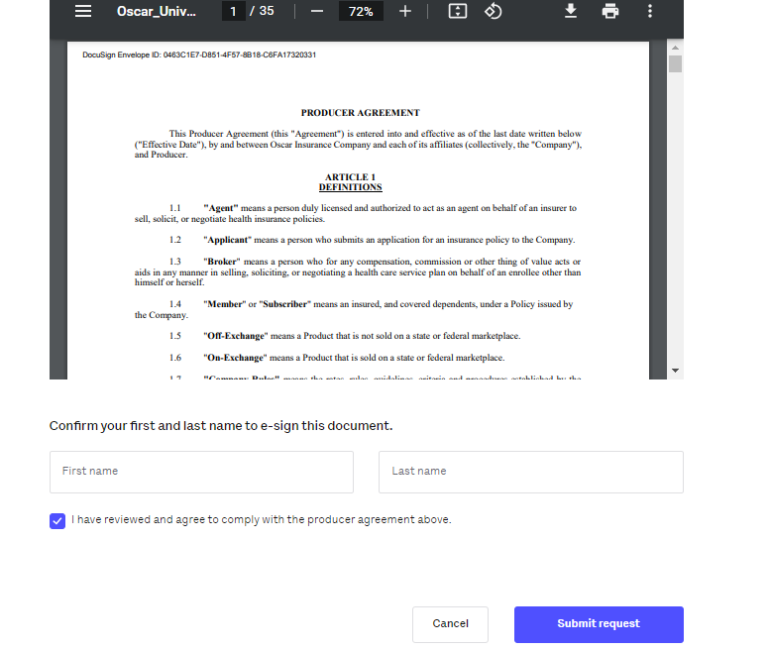
- To confirm that everything is correct, a screen similar to the following should appear (unless the agent is part of Estrella Insurance or Bortec Insurance agency, then instead of All Insurance Inc. it should be Bortec or Estrella).
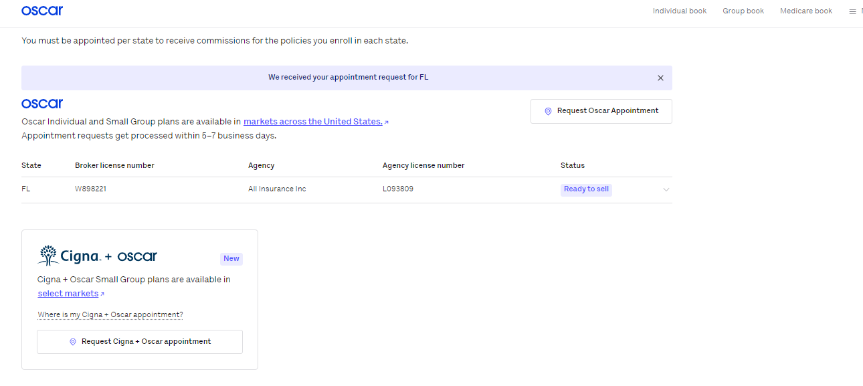

- At this point, the agent now has the Oscar contract. Please note that Oscar will not activate the contract until the agent submits their first sale. Until then, they will not have a Writing number; therefore, the update in Salesforce should be done as follows
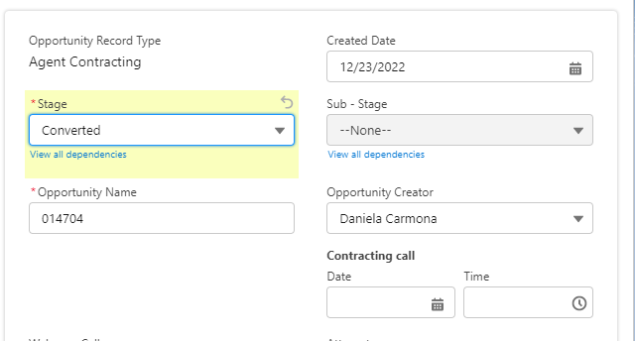
Note example:
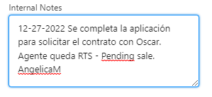
- Once the opportunity is updated, go to the contracting email informing the agents their predefined username and password, through a template named “OSCAR Appointment successful”

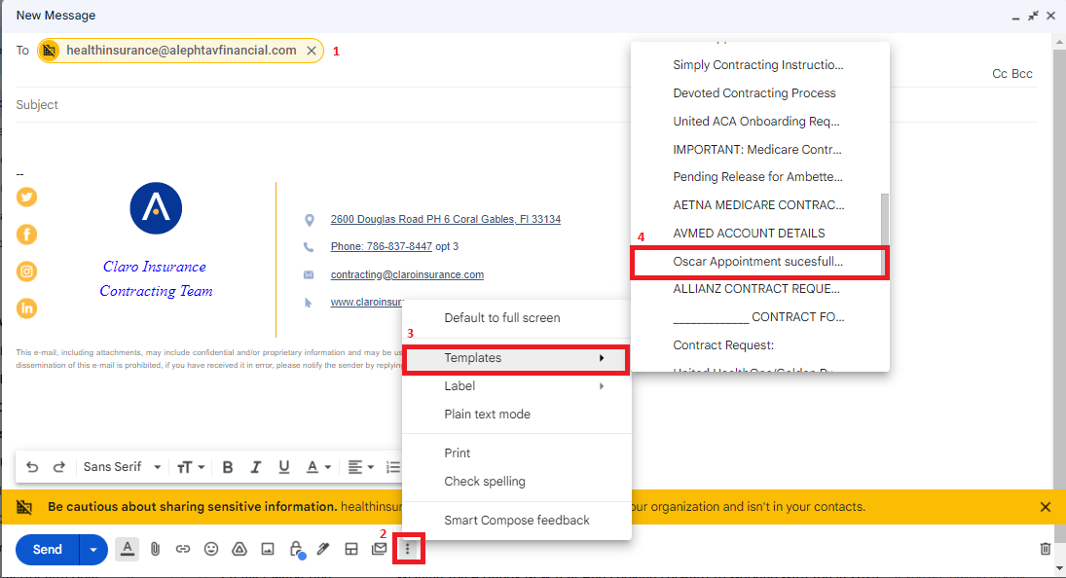

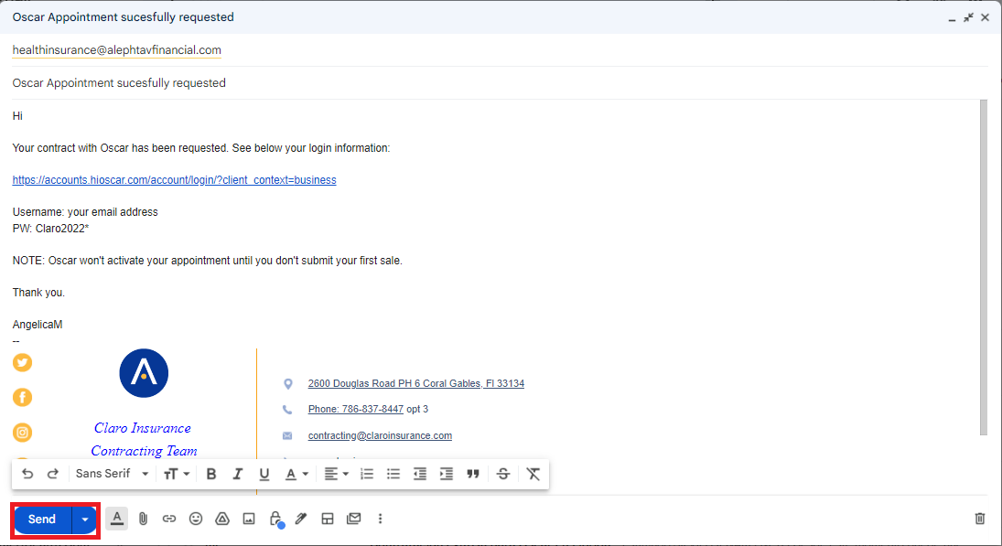

- In case the request is for adding a state:
You need to request the credentials through email. Upon receiving the credentials, you need to log in and request the contracts by clicking in appointments on the menu then click on “request Oscar appointment” and follow the steps 9 to 14.
